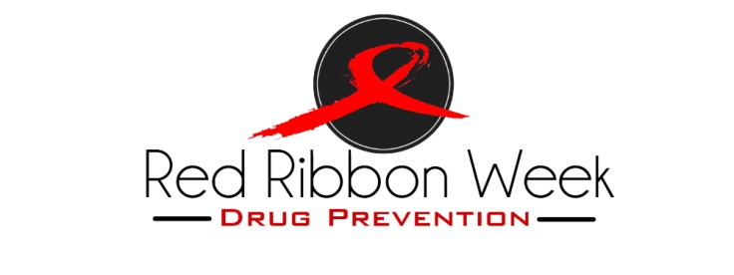
Dear Parents and Guardians,
During the week of October 23rd – 31st, 2015, we will celebrate Red Ribbon Week at (Name of School Here). Red Ribbon Week is a national effort in which schools and organizations raise awareness in the community about drug abuse. By wearing a red ribbon during the week, we are promoting healthy drug-free living.

Red Ribbon Week is dedicated to Federal drug enforcement agent Enrique Camarena, who in 1985 was killed by drug traffickers in Mexico. In response to his death, his close friends started what was then called, Camarena clubs. The movement spread to a national level and now we have what is called, Red Ribbon Week.

Red Ribbon Week is celebrated by over 100,000 schools and organizations nationwide, making it the most successful drug prevention event ever held and our school will join in on the celebration.

Each day throughout the week, children and staff will support the red ribbon initiative through various activities and theme days. In addition our students will watch a 10-12 minute video each day about illicit drugs. The topics covered include: History of Red Ribbon Week, Over-the-counter drugs, Marijuana, Prescription Drugs and Alcohol Abuse.
Our Red Ribbon Committee has developed activities that will be implemented throughout the week to promote a commitment on the part of everyone to a drug-free, alcohol-free, violence-free and smoke-free community. We hope that you will show your support for this initiative by reinforcing with your child/children the importance of maintaining a healthy lifestyle and helping them to say NO to drugs and YES to healthy living!
Thank you for taking the time to talk to your child this week about what they are learning in school.

Sincerely,
(Your Name Here)
Principal or Guidance Counselor

